
Symbiosis Institute of Technology, Pune
Faculty of Engineering
CSE- Academic Year 2026-27
Java Programming – Lab Batch 2025-29
Lab Assignment No:- 22
Name of Student | Aarushi Raizada
PRN No. | 25070122002
Batch | 2025-29
Class | A1
Academic Year & Semester | 2026 SEM III
Date of Submission | 10/10/26
Title of Assignment: | Demonstration and exploration of JDBC classes and interfaces (PreparedStatement, and ResultSet).
Theory  Practice questions | PreparedStatement is an advanced JDBC interface used to execute precompiled SQL statements with parameters. Unlike the Statement interface, PreparedStatement allows SQL queries to be compiled only once and executed multiple times with different values, thereby improving performance. It also protects applications against SQL injection attacks by separating SQL code from user input. The ResultSet interface stores the records returned by SQL SELECT queries. It provides various methods such as next(), getInt(), getString(), and getDouble() for accessing retrieved data. PreparedStatement and ResultSet together provide secure, efficient, and flexible database interaction and are widely used in enterprise Java applications.  - Create a login application using PreparedStatement to check username and password.  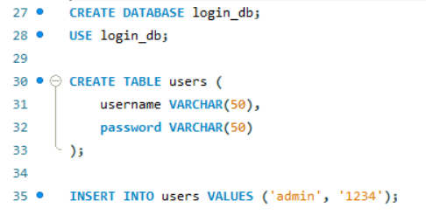  import java.sql.*;  import java.util.Scanner;  class LoginApp {  public static void main(String[] args) {  Scanner sc = new Scanner(System.in);  try {  Connection con = DriverManager.getConnection(  "jdbc:mysql://localhost:3306/login_db",  "root", "your_password"  );  System.out.print("Enter username: ");  String username = sc.nextLine();  System.out.print("Enter password: ");  String password = sc.nextLine();  String sql = "SELECT * FROM users WHERE username=? AND password=?";  PreparedStatement ps = con.prepareStatement(sql);  ps.setString(1, username);  ps.setString(2, password);  ResultSet rs = ps.executeQuery();  if (rs.next()) {  System.out.println("Login successful!");  } else {  System.out.println("Invalid username or password!");  }  con.close();  sc.close();  } catch (Exception e) {  System.out.println(e);  }  }  }  - Create a Java application using PreparedStatement to authenticate hospital staff login (doctor/nurse/login ID and password). Display appropriate access messages based on authentication result.  import javax.swing.*;  import java.awt.*;  import java.awt.event.ActionEvent;  import java.awt.event.ActionListener;  import java.sql.Connection;  import java.sql.DriverManager;  import java.sql.PreparedStatement;  import java.sql.ResultSet;  public class HospitalUI extends JFrame {  private static final String DB_URL = "jdbc:mysql://localhost:3306/hospital_db";  private static final String DB_USER = "root";  private static final String DB_PASSWORD = "Aarushi@7002";  public HospitalUI() {  setTitle("Hospital Portal System");  setSize(450, 350);  setDefaultCloseOperation(JFrame.EXIT_ON_CLOSE);  setLocationRelativeTo(null);  JTabbedPane tabbedPane = new JTabbedPane();  tabbedPane.addTab("General Login", createGeneralLoginPanel());  tabbedPane.addTab("Staff Login", createStaffLoginPanel());  add(tabbedPane);  }  private JPanel createGeneralLoginPanel() {  JPanel panel = new JPanel(new GridBagLayout());  GridBagConstraints gbc = new GridBagConstraints();  gbc.insets = new Insets(8, 8, 8, 8);  gbc.fill = GridBagConstraints.HORIZONTAL;  JLabel lblTitle = new JLabel("=== System Login ===", SwingConstants.CENTER);  lblTitle.setFont(new Font("Arial", Font.BOLD, 16));  JLabel lblUser = new JLabel("Username:");  JTextField txtUser = new JTextField(15);  JLabel lblPass = new JLabel("Password:");  JPasswordField txtPass = new JPasswordField(15);  JButton btnLogin = new JButton("Login");  JLabel lblStatus = new JLabel("", SwingConstants.CENTER);  gbc.gridx = 0; gbc.gridy = 0; gbc.gridwidth = 2;  panel.add(lblTitle, gbc);  gbc.gridwidth = 1;  gbc.gridx = 0; gbc.gridy = 1;  panel.add(lblUser, gbc);  gbc.gridx = 1; gbc.gridy = 1;  panel.add(txtUser, gbc);  gbc.gridx = 0; gbc.gridy = 2;  panel.add(lblPass, gbc);  gbc.gridx = 1; gbc.gridy = 2;  panel.add(txtPass, gbc);  gbc.gridx = 0; gbc.gridy = 3; gbc.gridwidth = 2;  panel.add(btnLogin, gbc);  gbc.gridx = 0; gbc.gridy = 4; gbc.gridwidth = 2;  panel.add(lblStatus, gbc);  btnLogin.addActionListener(new ActionListener() {  @Override  public void actionPerformed(ActionEvent e) {  String username = txtUser.getText();  String password = new String(txtPass.getPassword());  String query = "SELECT * FROM users WHERE username = ? AND password = ?";  try (Connection conn = DriverManager.getConnection(DB_URL, DB_USER, DB_PASSWORD);  PreparedStatement pstmt = conn.prepareStatement(query)) {  pstmt.setString(1, username);  pstmt.setString(2, password);  try (ResultSet rs = pstmt.executeQuery()) {  if (rs.next()) {  lblStatus.setForeground(Color.GREEN.darker());  lblStatus.setText("Login Successful! Welcome, " + rs.getString("username") + ".");  } else {  lblStatus.setForeground(Color.RED);  lblStatus.setText("Invalid Username or Password.");  }  }  } catch (Exception ex) {  lblStatus.setForeground(Color.RED);  lblStatus.setText("Database Error: " + ex.getMessage());  }  }  });  return panel;  }  private JPanel createStaffLoginPanel() {  JPanel panel = new JPanel(new GridBagLayout());  GridBagConstraints gbc = new GridBagConstraints();  gbc.insets = new Insets(8, 8, 8, 8);  gbc.fill = GridBagConstraints.HORIZONTAL;  JLabel lblTitle = new JLabel("=== Hospital Staff Portal ===", SwingConstants.CENTER);  lblTitle.setFont(new Font("Arial", Font.BOLD, 16));  JLabel lblStaffId = new JLabel("Staff ID:");  JTextField txtStaffId = new JTextField(15);  JLabel lblPass = new JLabel("Password:");  JPasswordField txtPass = new JPasswordField(15);  JButton btnLogin = new JButton("Login");  JLabel lblStatus = new JLabel("", SwingConstants.CENTER);  gbc.gridx = 0; gbc.gridy = 0; gbc.gridwidth = 2;  panel.add(lblTitle, gbc);  gbc.gridwidth = 1;  gbc.gridx = 0; gbc.gridy = 1;  panel.add(lblStaffId, gbc);  gbc.gridx = 1; gbc.gridy = 1;  panel.add(txtStaffId, gbc);  gbc.gridx = 0; gbc.gridy = 2;  panel.add(lblPass, gbc);  gbc.gridx = 1; gbc.gridy = 2;  panel.add(txtPass, gbc);  gbc.gridx = 0; gbc.gridy = 3; gbc.gridwidth = 2;  panel.add(btnLogin, gbc);  gbc.gridx = 0; gbc.gridy = 4; gbc.gridwidth = 2;  panel.add(lblStatus, gbc);  btnLogin.addActionListener(new ActionListener() {  @Override  public void actionPerformed(ActionEvent e) {  String staffId = txtStaffId.getText();  String password = new String(txtPass.getPassword());  String query = "SELECT role FROM hospital_staff WHERE staff_id = ? AND password = ?";  try (Connection conn = DriverManager.getConnection(DB_URL, DB_USER, DB_PASSWORD);  PreparedStatement pstmt = conn.prepareStatement(query)) {  pstmt.setString(1, staffId);  pstmt.setString(2, password);  try (ResultSet rs = pstmt.executeQuery()) {  if (rs.next()) {  String role = rs.getString("role");  lblStatus.setForeground(Color.GREEN.darker());  if ("Doctor".equalsIgnoreCase(role)) {  lblStatus.setText("Access Granted: Welcome, Dr. " + staffId);  } else if ("Nurse".equalsIgnoreCase(role)) {  lblStatus.setText("Access Granted: Welcome, Nurse " + staffId);  } else {  lblStatus.setText("Access Granted: Welcome, Staff member.");  }  } else {  lblStatus.setForeground(Color.RED);  lblStatus.setText("Authentication Failed: Invalid Staff ID or Password.");  }  }  } catch (Exception ex) {  lblStatus.setForeground(Color.RED);  lblStatus.setText("Database Error: " + ex.getMessage());  }  }  });  return panel;  }  public static void main(String[] args) {  SwingUtilities.invokeLater(() -> {  new HospitalUI().setVisible(true);  });  }  }  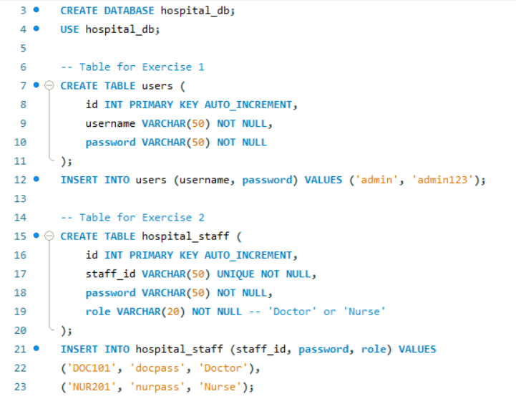
Output Screenshots (if applicable) | Ans1  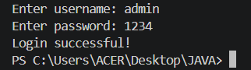  Ans 2  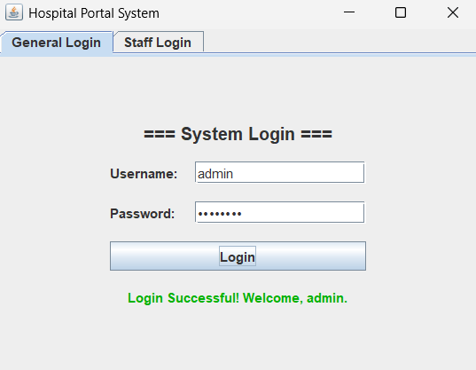
Conclusion | Thus, we successfully developed login applications using JDBC and PreparedStatement. The programs validate user credentials against MySQL records and display appropriate messages for successful authentication, doctor or nurse access, and invalid login attempts

